**Week 1 - S1 - Lab Problem**

**Name: Ramesh Harisabapathi Chettiar**

**Roll Number: RA2411030010263**

**Course: Networking and Communications**

**Semester: 3**

**Date of Submission: 19/08/2025**

**Lab Practice Programs (Any Six)**

**1. Write a program to find and return the length of a string without using the length() method**

**Hint =>**

**a. Take user input using the Scanner next() method**

**b. Create a method to find and return a string's length without using the built-in length()**

**method. The logic for this is to use the infinite loop to count each character till the**

**charAt() method throws a runtime exception, handles the exception, and then return**

**the count**

**c. The main function calls the user-defined method as well as the built-in length() method**

**and displays the result**

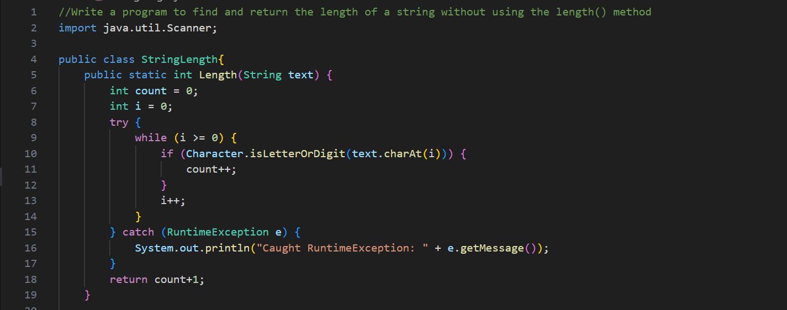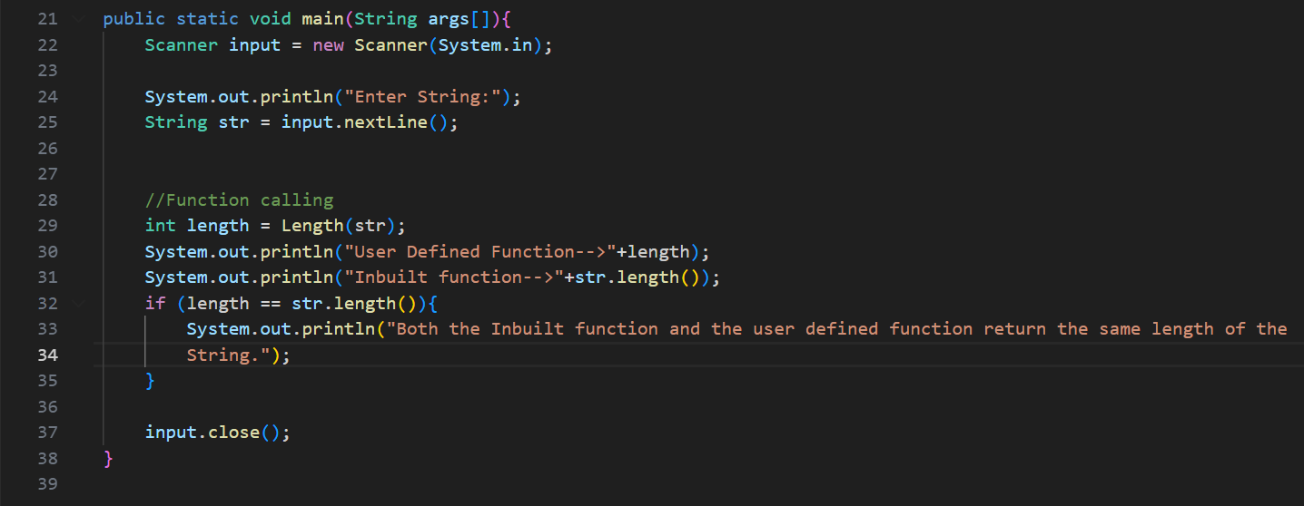

**5. Write a program to find vowels and consonants in a string and display the count of Vowels and Consonants in the string**

**Hint =>**

**a. Create a method to check if the character is a vowel or consonant and return the result.**

**The logic used here is as follows:**

**i. Convert the character to lowercase if it is an uppercase letter using the ASCII values**

**of the characters**

**ii. Check if the character is a vowel or consonant and return Vowel, Consonant, or Not**

**a Letter**

**b. Create a Method to Method to find vowels and consonants in a string using charAt()**

**method and finally return the count of vowels and consonants in an array**

**c. Finally, the main function takes user inputs, calls the user-defined methods, and displays the result.**

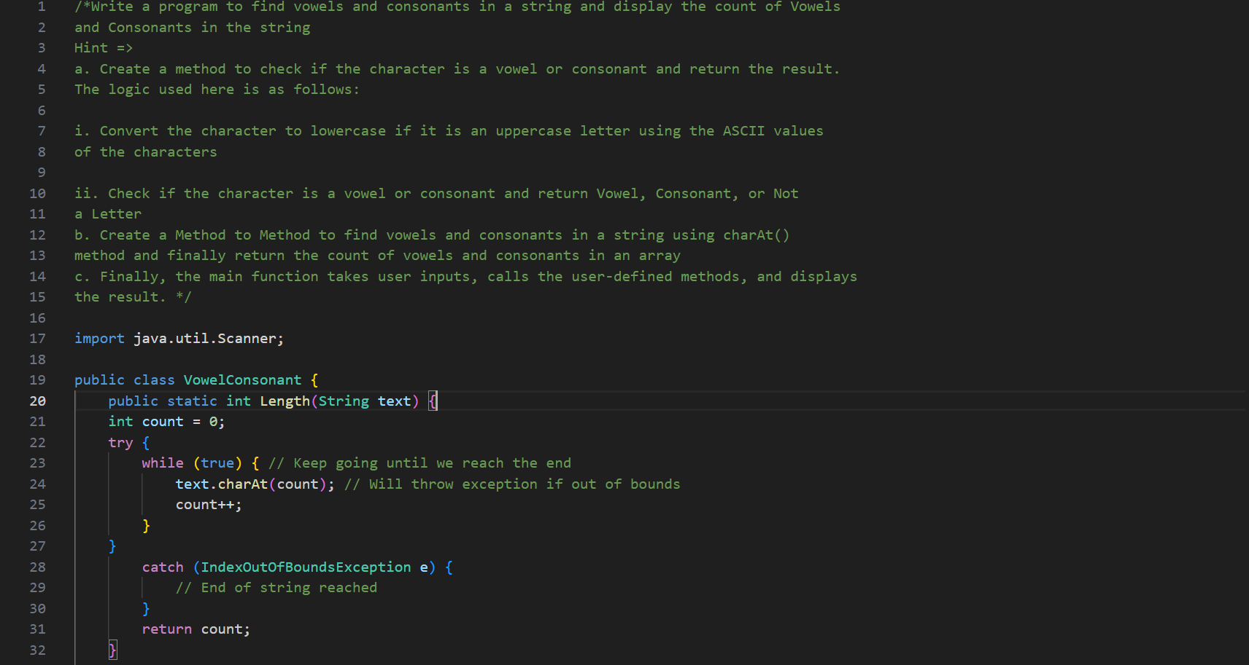

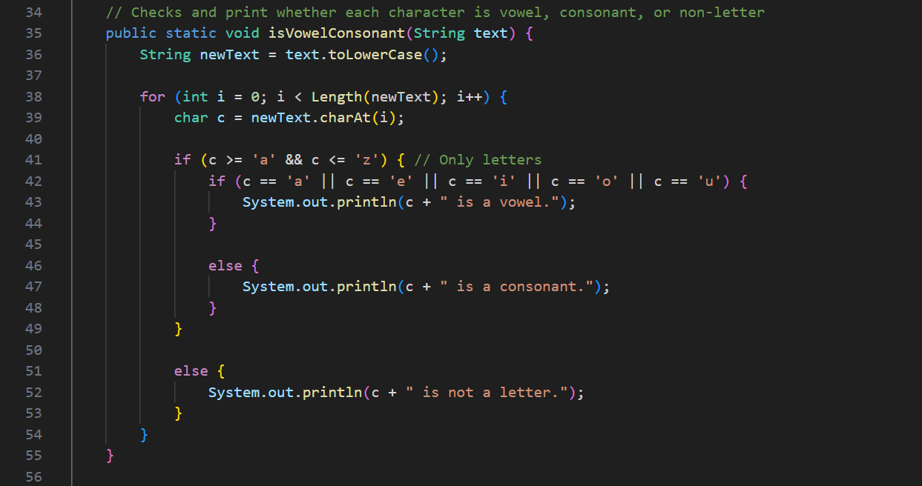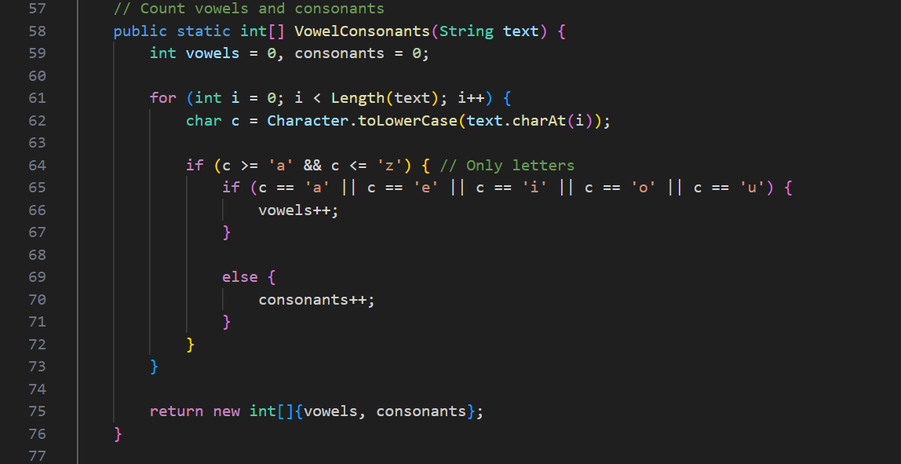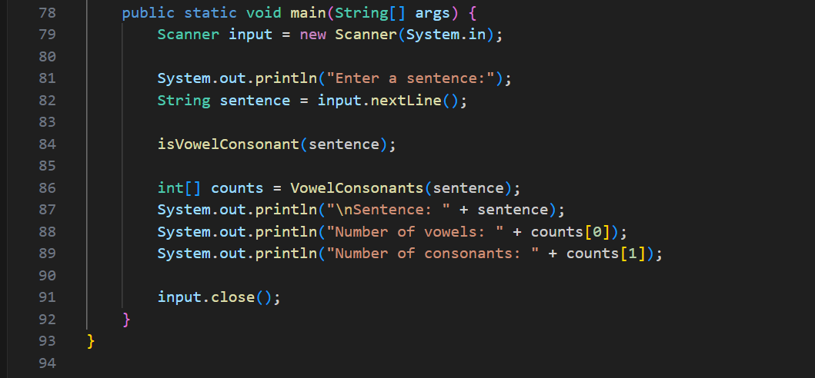

**6.Write a program to find vowels and consonants in a string and display the character type -**

**Vowel, Consonant, or Not a Letter**

**Hint =>**

**a. Create a method to check if the character is a vowel or consonant and return the result.**

**The logic used here is as follows:**

**i. Convert the character to lowercase if it is an uppercase letter using the ASCII values**

**of the characters**

**ii. Check if the character is a vowel or consonant and return Vowel, Consonant, or Not**

**a Letter**

**b. Create a Method to find vowels and consonants in a string using charAt() method and**

**return the character and vowel or consonant in a 2D array**

**c. Create a Method to display the 2D Array of Strings in a Tabular Format**

**d. Finally, the main function takes user inputs, calls the user-defined methods, and displays the result.**

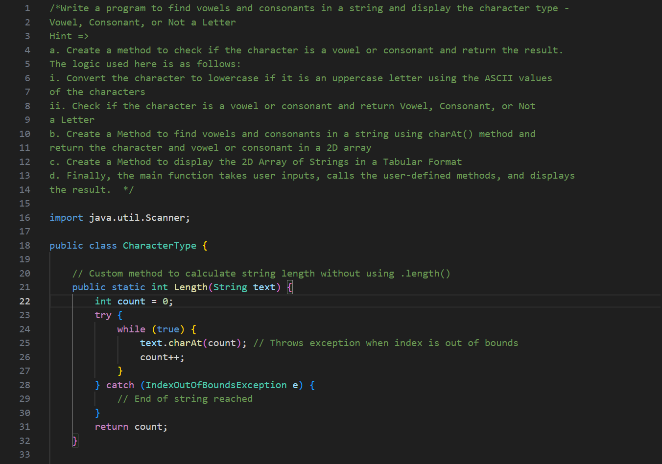

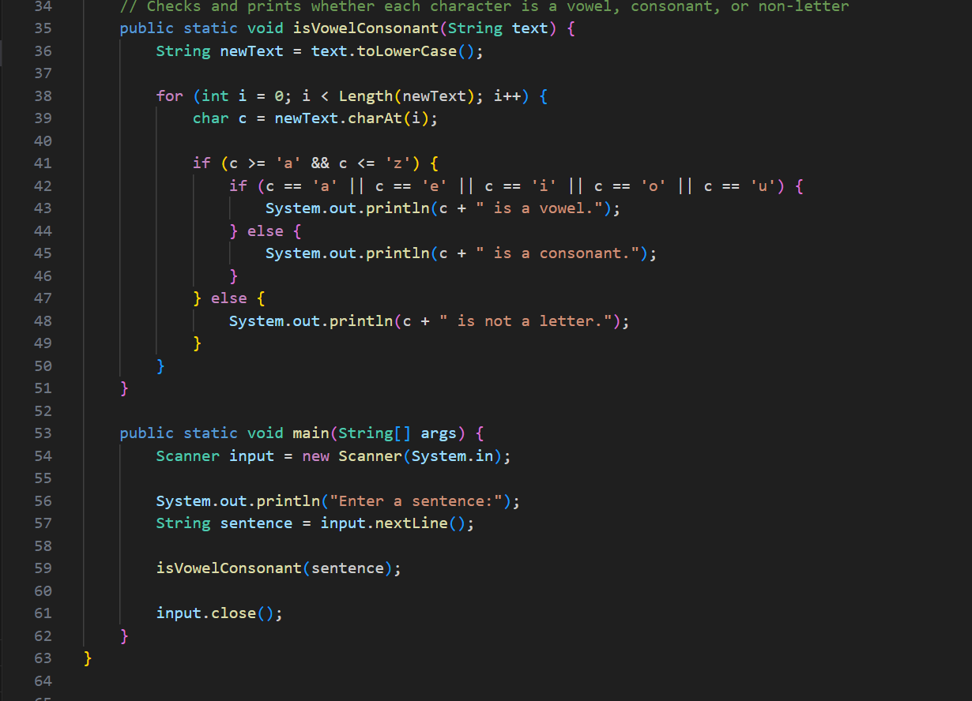

**7. Write a program to trim the leading and trailing spaces from a string using the charAt()**

**method**

**Hint =>**

**a. Create a method to trim the leading and trailing spaces from a string using the charAt()**

**method. Inside the method run a couple of loops to trim leading and trailing spaces and**

**determine the starting and ending points with no spaces. Return the start point and end**

**point in an array**

**b. Write a method to create a substring from a string using the charAt() method with the**

**string, start, and end index as the parameters**

**c. Write a method to compare two strings using the charAt() method and return a Boolean result**

**d. The main function calls the user-defined trim and substring methods to get the text after**

**trimming the leading and trailing spaces. Post that use the String built-in method trim()**

**to trim spaces and compare the two strings. And finally display the result**

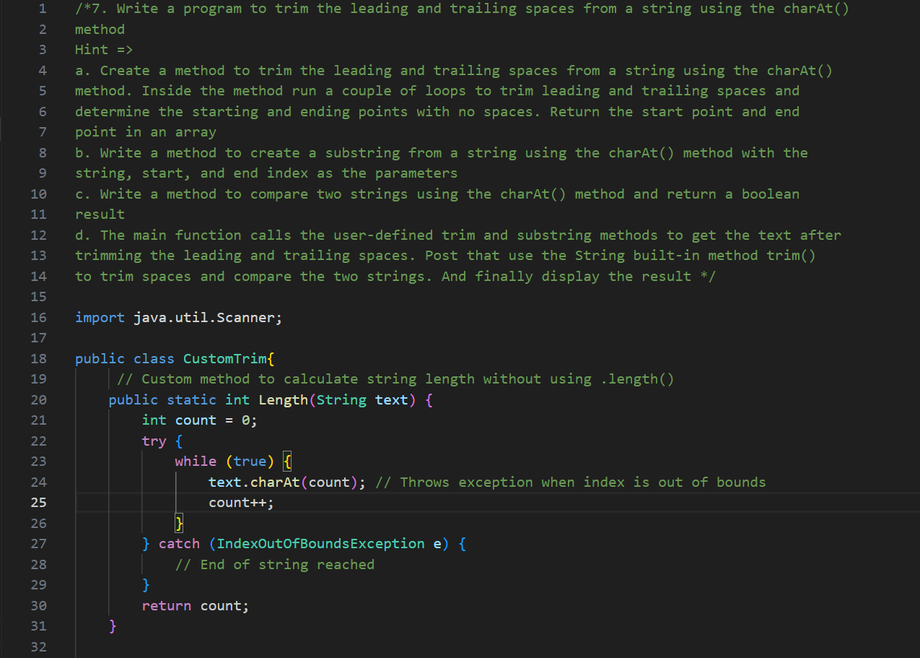

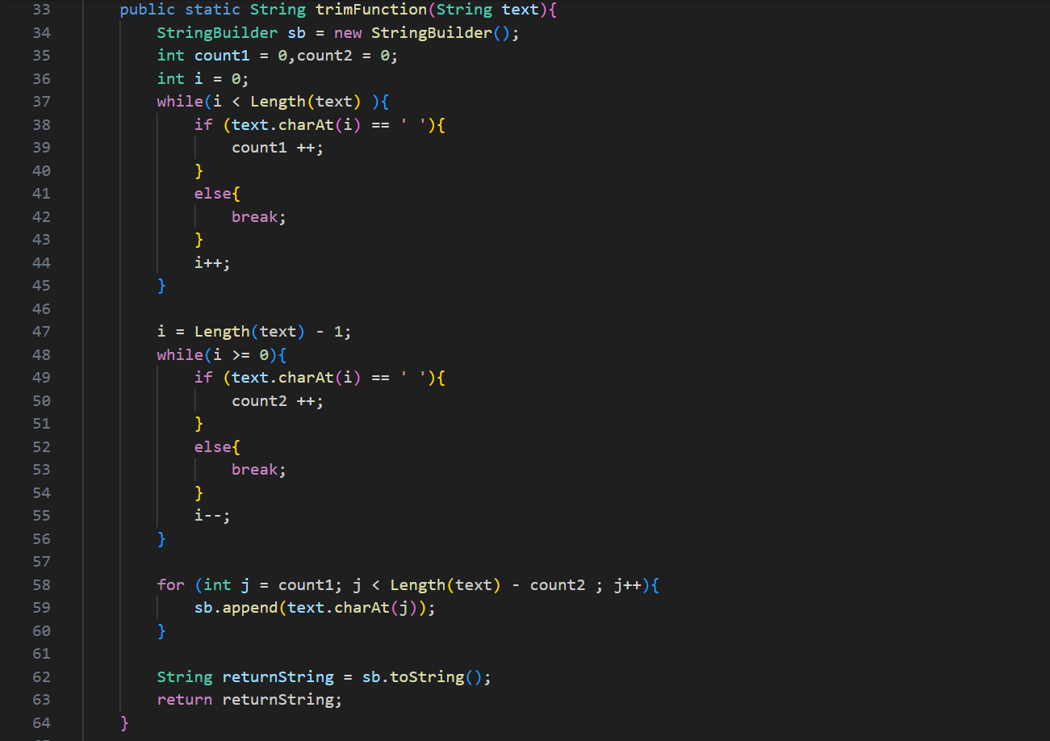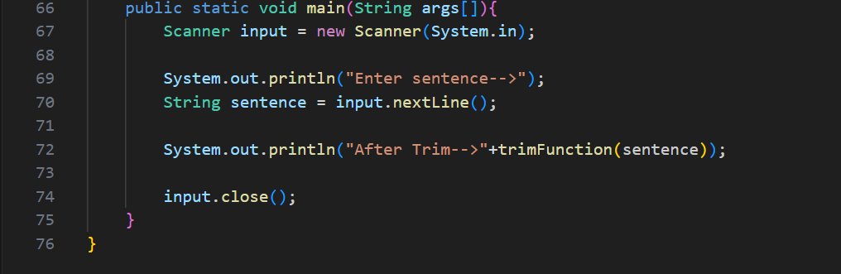

**8. Write a program to take user input for the age of all 10 students in a class and check**

**whether the student can vote depending on his/her age is greater or equal to 18.**

**Hint =>**

**a. Create a method to define the random 2-digit age of several students provided as**

**method parameters and return a 1D array of ages of n students**

**b. Create a method that takes an array of age as a parameter and returns a 2D String array of age and a boolean true or false to indicate can and cannot vote. Inside the method firstly validate the age for a negative number, if a negative cannot vote. For valid age check for age is 18 or above to set true to indicate can vote.**

**c. Create a method to display the 2D array in a tabular format.**

**d. Finally, the main function takes user inputs, calls the user-defined methods, and displays the result.**

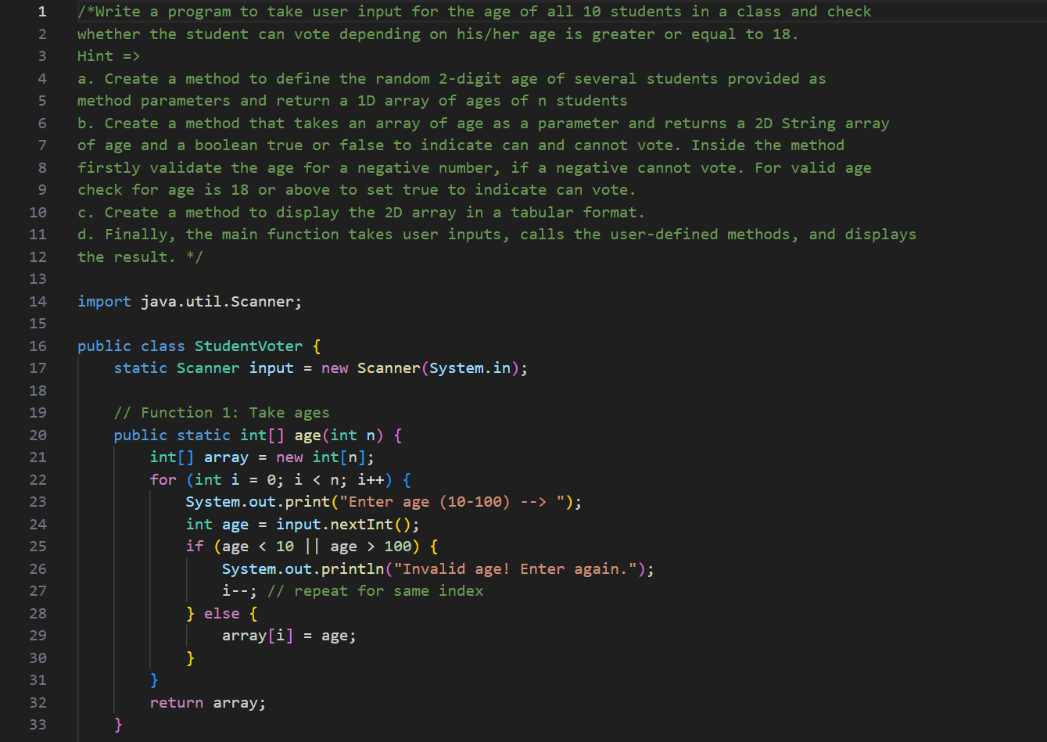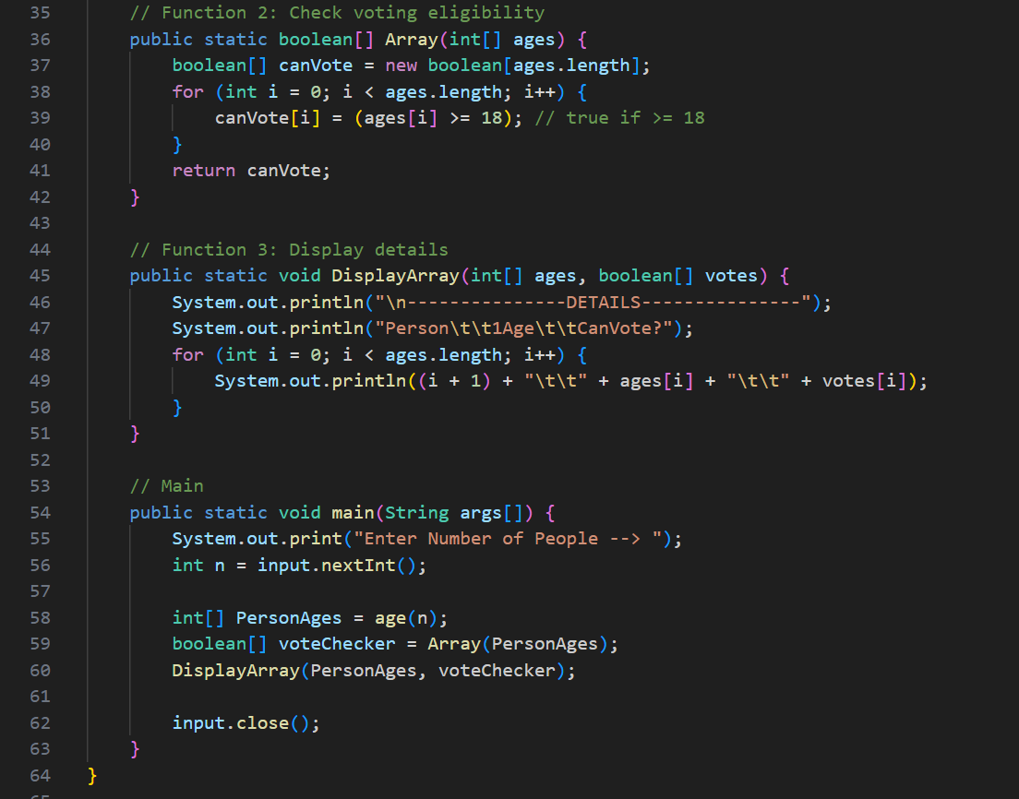

**9. Rock-Paper-Scissors is a game played between a minimum of two players. Each player can**

**choose either rock, paper, or scissors. Here the game is played between a user and a**

**computer. Based on the rules, either a player or a computer will win. Show the stats of**

**player and computer win in a tabular format across multiple games. Also, show the winning**

**percentage between the player and the computer.**

**Hint =>**

**a. The rule is: rock-scissors: rock will win (rock crushes scissors); rock-paper: paper wins**

**(paper covers rock); scissors-paper: scissors win (scissors cuts paper)**

**b. Create a Method to find the Computer Choice using the Math.random**

**c. Create a Method to find the winner between the user and the computer**

**d. Create a Method to find the average and percentage of wins for the user and the**

**computer and return a String 2D array**

**e. Create a Method to display the results of every game and also display the average and**

**percentage wins**

**f. In the main take user input for the number of games and call methods to display results**

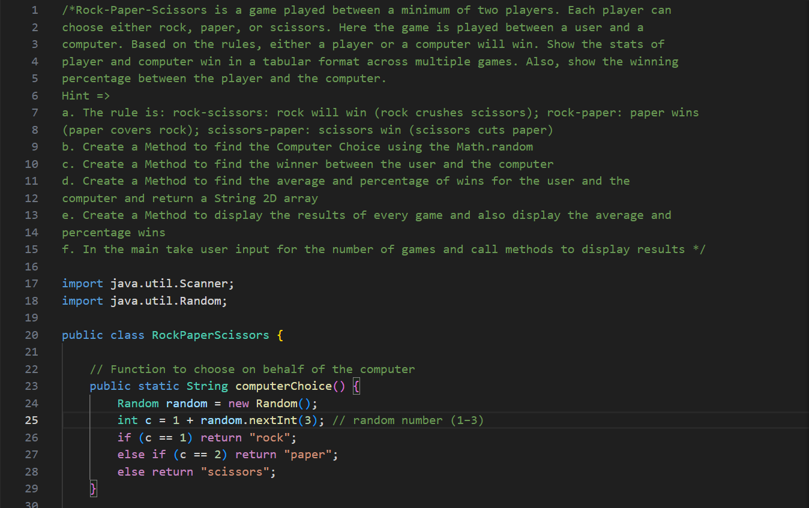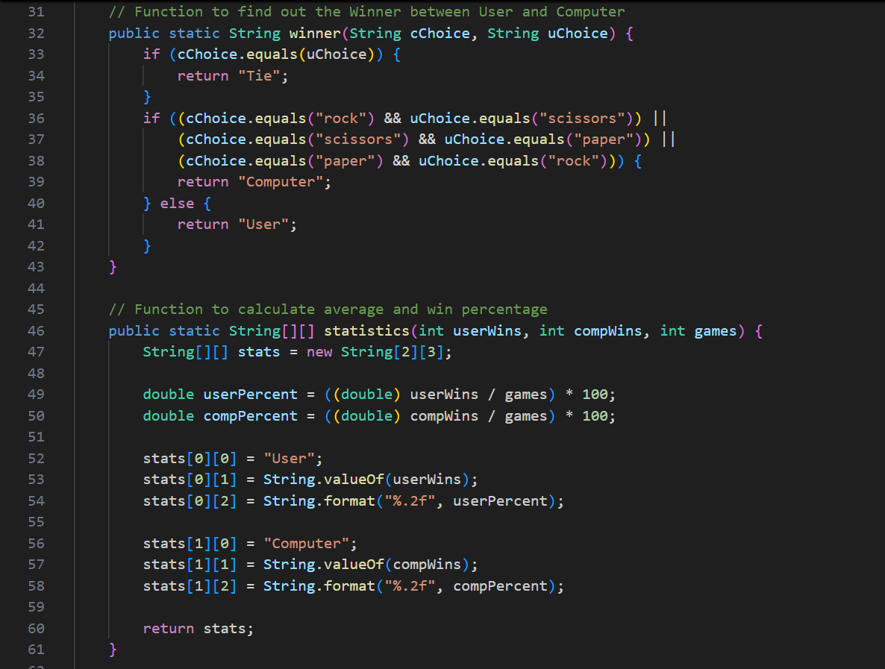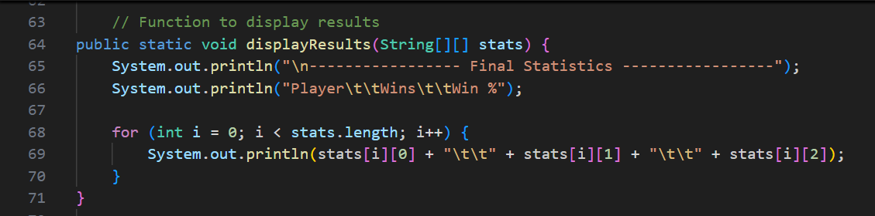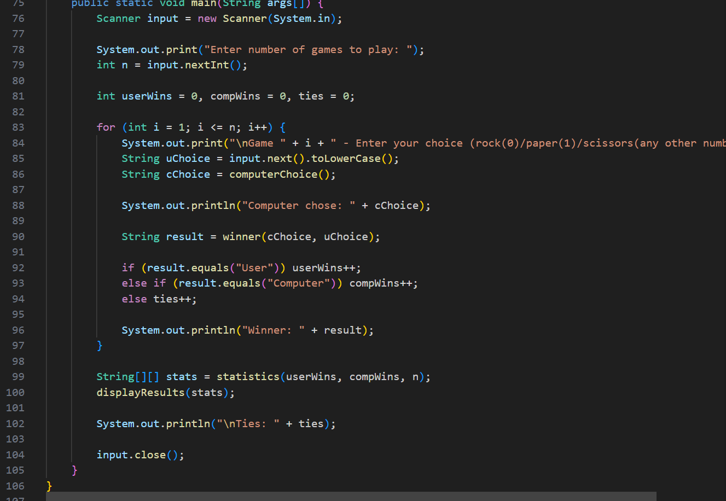

**OUTPUTS**

1. 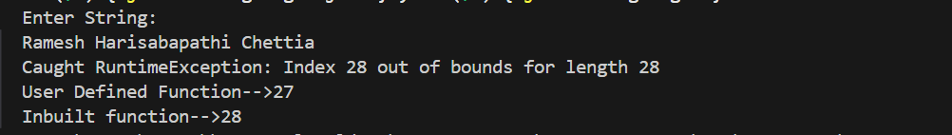

5. 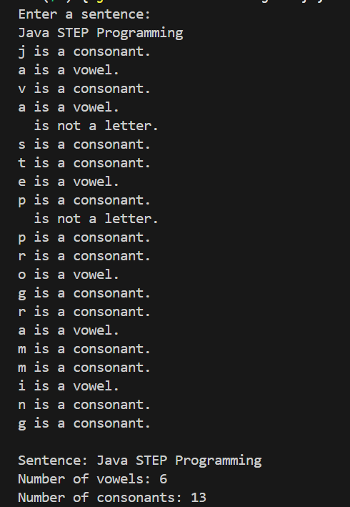

6. 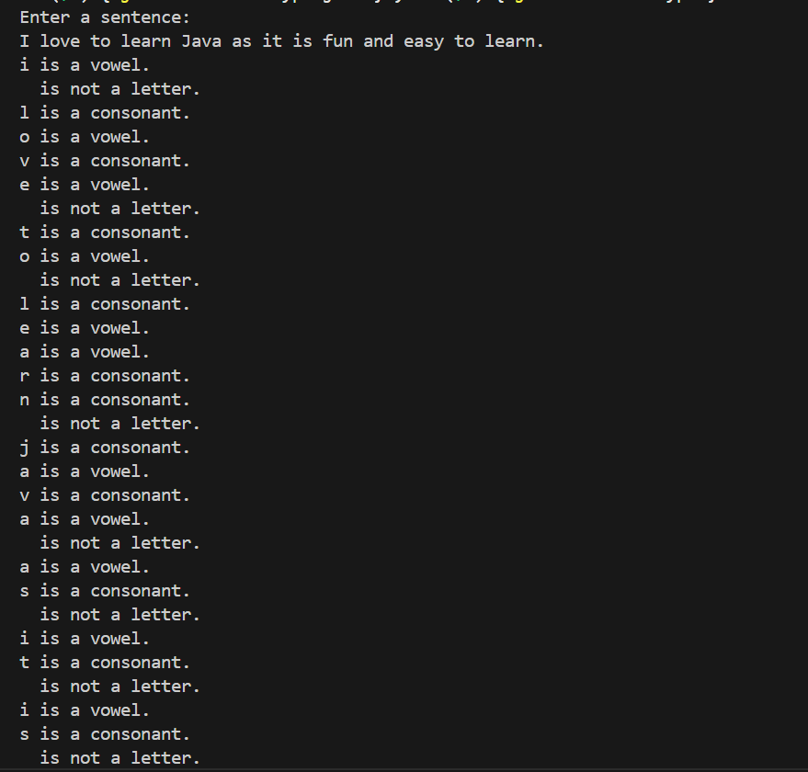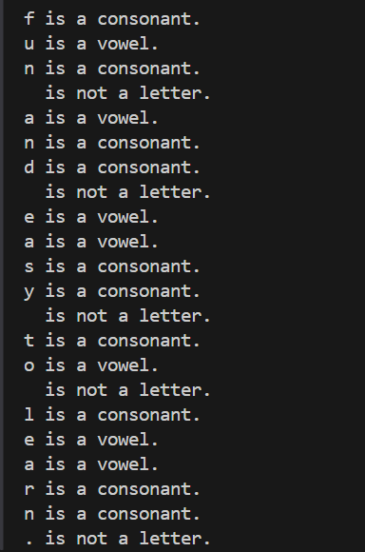

7. 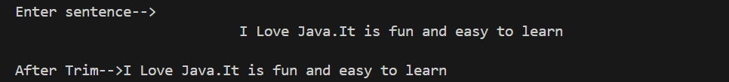

8. 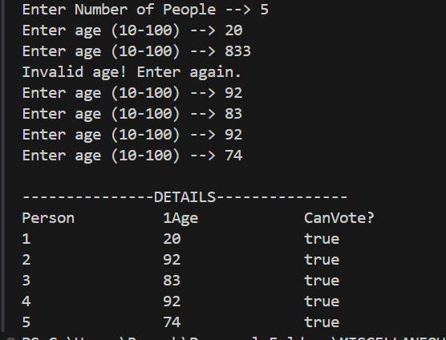

9. 